**Diet of a volleyball player: -**

1. Daily intake of nutrient rich carbohydrates, lean protein and healthy fat foods with lots of fruit and vegetables.
2. Well hydration is required for daily training as volleyball require high metabolic rate and physical involvement due to intensity of match.
3. During competition, following things must be followed: -
4. Meal should be taken 2-4 hours before the match.
5. Avoid meals leading to unexpected problems during the match.
6. Try eating liquid carbohydrates if having problem with the solid foods.
7. Electrolyte drinking is important for longer matches of approx. 1 hour.
8. The player must eat throughout the day to keep its body hydrated with giving the energy to the body.
9. Breakfast must not be skipped by the player, before going to the practice.
10. Being an intense, quick and power-driven game, primarily anaerobic muscle energy must be provided.
11. Following is the chart of calories used per minute according to the weight: -

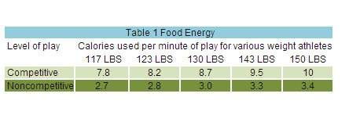

1. Some portable snacks for before match snack are suggested as follows:-
2. Fresh fruit,
3. Nut bars,
4. Homemade baked goods,
5. Custard/yoghurt,
6. Sandwich, etc.
7. After the match, here are some recommended recovery food that are suggested below: -
8. Sports bars,
9. Flavoured/chocolate milk,
10. Grainy sandwich,
11. Yoghurt with fruits added,
12. Some homemade protein foods, etc.

**Exercises for a volleyball player**

1. **Morning exercise/Single leg RDL to overhead press**: - 3 sets of 10 reps each with dumbbells, which is good for glute strength, hamstring and legs for vertical jumps.
2. **Overhead Press: -** 3 sets of 10 set each side, holding the plate at opposite positions, making this exercise efficient for building the core and upper body strength.
3. **Lunge with a twist**: - 3 sets of 8 reps each side of the body holding a plate, strengthen the legs and makes ankles more stable.
4. **Lateral lunge with a press: -** 3sets of 10 reps of each side using a plate developing quicker side to side moves and strengthen the arms for a stable digging and passing.
5. **Dumbbell snatch:** - 3 sets of 8 reps of it is better for triple extension, power development and improving explosiveness.